# Business Problem

The project aims to conduct a data analysis to identify strategies for increasing the occupancy rate, optimizing pricing, and enhancing customer experience to overcome these challenges and improve overall profitability in the aviation industry due to stricter environmental regulations, higher flight taxes, increased fuel prices, and a tight labor market causing rising labor costs. 

# Main Challenges

1. **Stricter environmental regulations:** Growing pressure on the aviation sector to reduce its carbon footprint has led to stricter environmental regulations that increase operating costs and limit future growth.
2. **Higher flight taxes:** Governments all throughout the world are taxiing airplanes more heavily, which boosts the cost of flying and reduces demand, in an effort to reduce environmental problems and make more money.
3. **Tight labor market resulting in increased labor costs:** The aviation industry's shortage of trained workers has driven up labor costs and turnover rates.

# Objectives

1. **Increase occupancy rate:** We can raise average revenue per seat and lessen the effects of the challenges we face by raising the occupancy rate..
2. **Improve pricing strategy:** To attract and retain customers, we must devise a pricing plan that takes into consideration the shifting market dynamics and consumer preferences.
3. **Enhance customer experience:** To attract and retain customers, we must devise a pricing plan that takes into consideration the shifting market dynamics and consumer preferences.

# The ultimate purpose of this assignment is to find ways to boost the occupancy rate on underperforming flights, which can ultimately result in higher airline profitability.

# Basic Analysis

The fundamental data analysis reveals information on the number of aircraft with more than 100 seats, the evolution of the total number of tickets sold and revenue earned over time, and the average fare for each aircraft with various pricing conditions. The development of initiatives to raise occupancy rates and improve pricing for each aircraft will benefit from these findings. The aircraft having more than 100 seats are included in Table 1 together with the exact seat count.

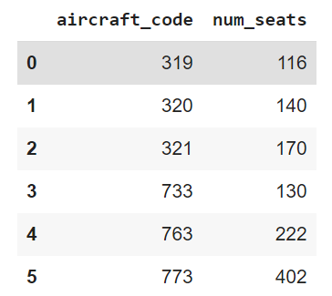

## Table 1

I have used a line chart visualization to get a better grasp of the trend in ticket bookings and the money generated by those bookings. When we analyze the chart, we see that the number of tickets purchased shows a gradual rise from June 22nd to July 7th, followed by a pattern that is mostly stable from July 8th until August, with a clear peak in ticket purchases where the most tickets were purchased on a single day. It is significant to note that the company's revenue from these bookings is directly correlated with the quantity of tickets purchased. As a result, we can observe a similar pattern in the company's

Overall revenue throughout the investigated time frame.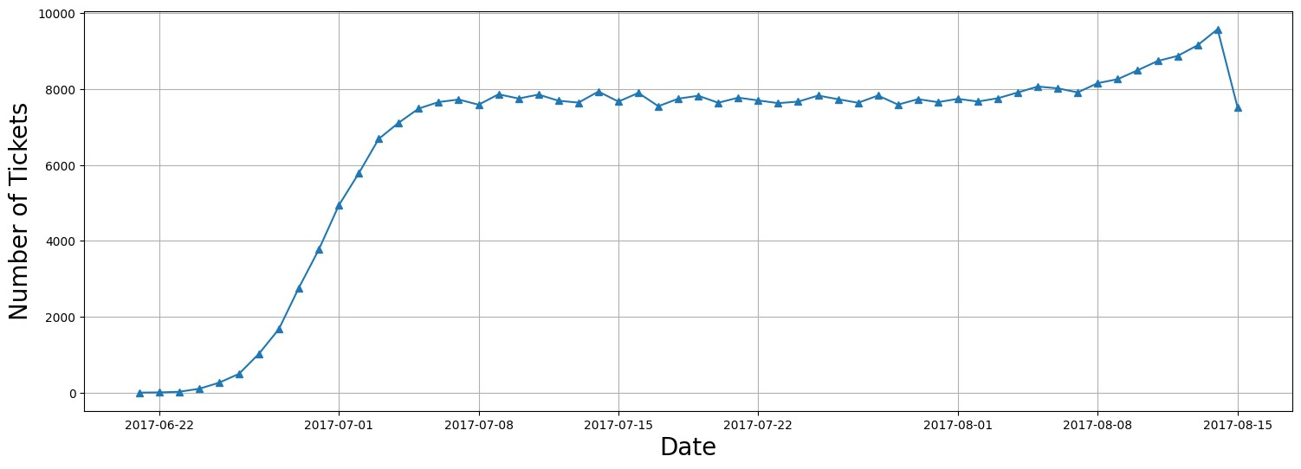

## Figure 1

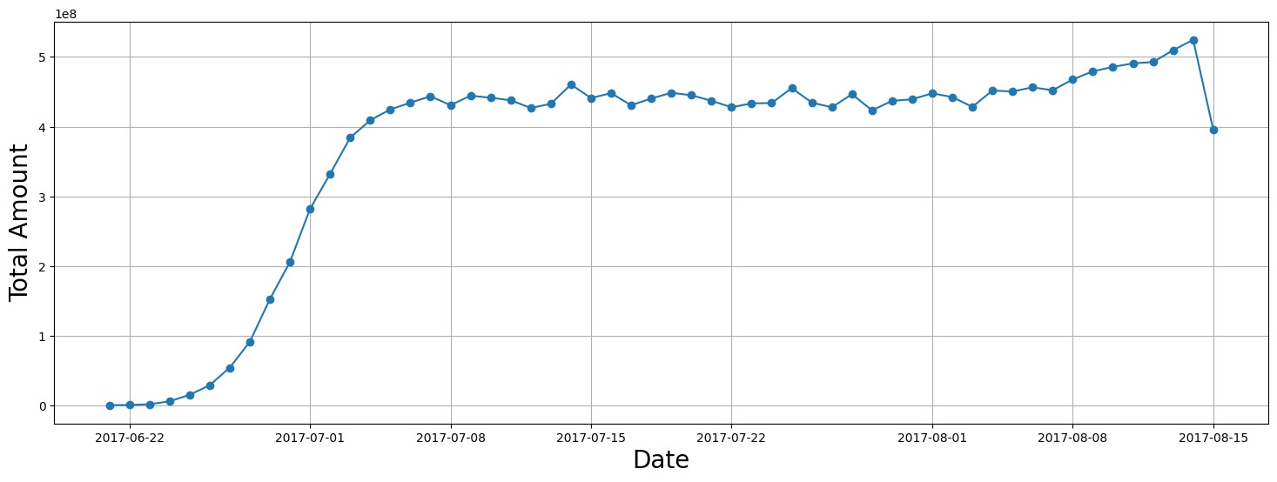

## Figure 2

After completing the calculations for the typical expenses associated with various fare conditions for each aircraft, I was able to produce a bar graph to visually compare the data. The data for three different categories of fares—business, economy, and comfort—are displayed in Figure 3. It is important to note that only the 773 is equipped with the comfort class. On the other hand, the CN1 and CR2 aircraft only provide the economy class. The costs for business class are consistently higher than those for economy class when comparing various pricing scenarios within each aircraft. Regardless of the fare terms, this trend may be observed on all aircraft.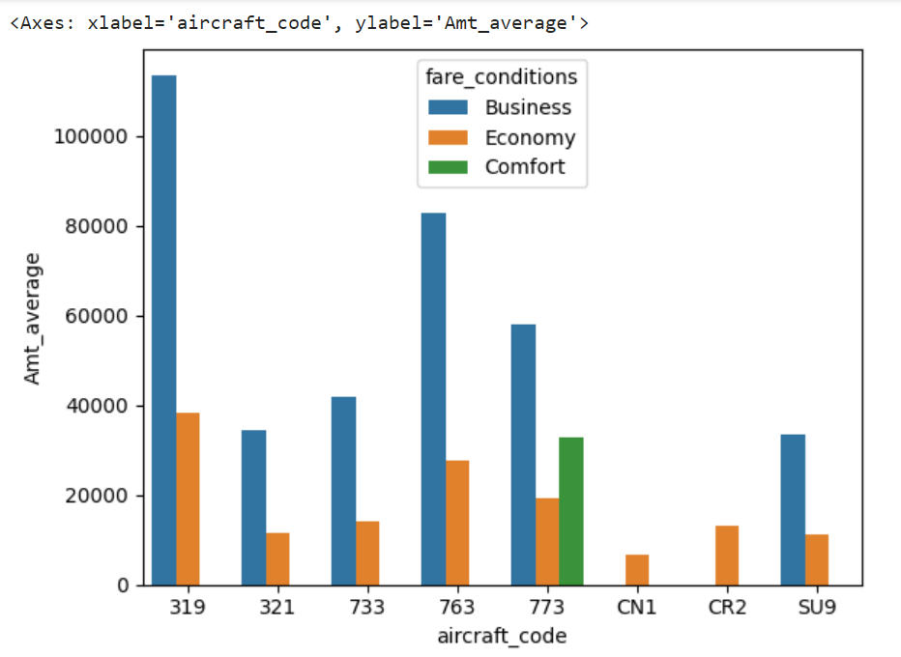

**Figure 3**

# Analyzing occupancy rate

For airlines to be as profitable as possible, a thorough analysis of their income streams is required. Important indicators to take into account include each aircraft's average revenue per ticket as well as the total annual income. Airlines may utilize this data to identify the aircraft types and routes that bring in the most money and adjust their operations accordingly. Additionally, by finding opportunities for pricing optimization and allocating resources to more lucrative routes, this research can help. Figure 4 below displays each aircraft's total income, total tickets sold, and average revenue per ticket. The aircraft with the highest overall income is SU9, and as can be seen in figure 3, this aircraft has the lowest prices for both business class and economy class. This may be the cause of the majority of passengers purchasing this flight because it is less expensive than alternatives. The airplane with the lowest total income is the CN1, and one explanation for this could be that it only offers economy class at the lowest prices, or that it has less amenities 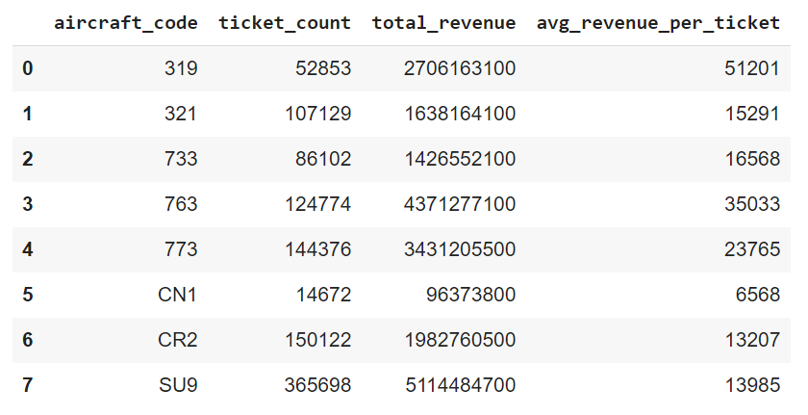or subpar conditions.

## Figure 4

Another important factor to consider is the average occupancy per aircraft. Using this metric, airlines may assess how well they fill their seats and identify opportunities to increase occupancy rates. Increased occupancy rates can reduce operating costs related to empty seats while also assisting airlines in increasing revenue and profitability. Customer satisfaction, airline scheduling, and pricing policies are all variables that could affect occupancy rates. The average number of booked seats for each aircraft is depicted in figure 5 below. By dividing the number of reserved seats by the total number of seats, the occupancy rate is derived. A higher occupancy rate indicates that more passengers have made reservations for the available seats on the aircraft.

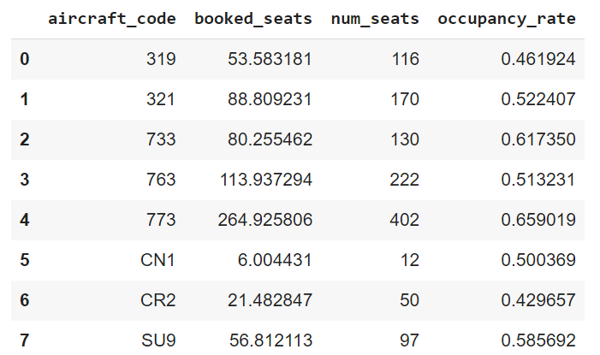

## Figure 5

To further explore the potential advantages of improving occupancy rates, airlines can calculate how much their whole yearly turnover could increase by giving all aircraft a 10% higher occupancy rate. This study can help airlines decide whether increasing occupancy rates is a practical strategy and will have a positive financial impact. By maximizing pricing strategies and other operational considerations, airlines can increase occupancy rates and revenue while providing customers with superior value and service. The figure below demonstrates how total income increased when the occupancy rate was raised by 10%. It indicates that this increase will happen gradually, therefore airlines should concentrate more on pricing strategies. 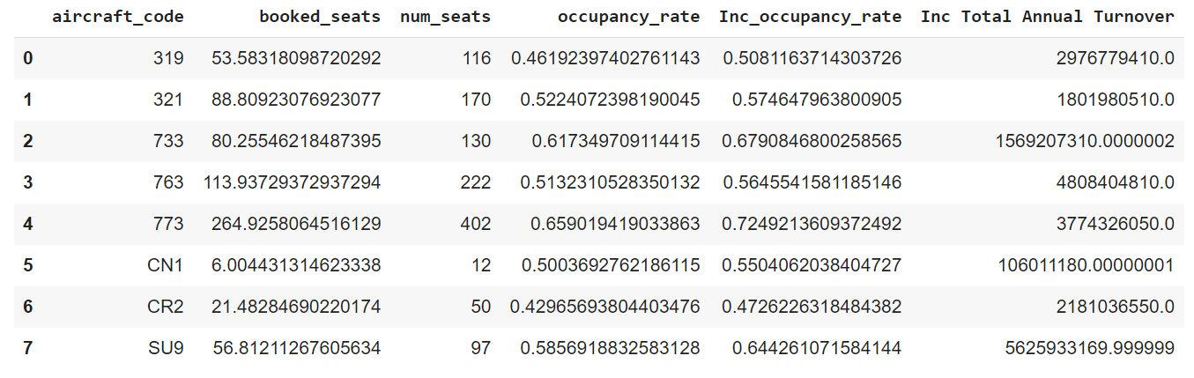

**Figure 6**

# Conclusion

In conclusion, it is crucial for airlines looking to maximize profitability to analyze revenue data such as total revenue per year, average revenue per ticket, and average occupancy per aircraft. By analyzing these variables, airlines can identify areas for improvement and alter their price and route plans. An essential factor that might improve profitability is a higher occupancy rate, which enables airlines to maximize revenue while avoiding expenditures related to empty seats. The airline needs to adjust the prices for each aircraft because consumers aren't purchasing tickets for those aircrafts due to low and high prices, respectively. According to the aircraft's condition and amenities, they should determine a fair price that is neither too low nor too excessive.

Additionally, improving occupancy rates shouldn't come at the expense of customer safety or satisfaction. Airlines need to balance the importance of making a profit with the importance of providing top-notch service and maintaining safety rules. Airlines that use a data-driven approach to revenue analysis and optimization may find long-term success in a highly competitive industry.